Criterion B: Design

Diagram:

The Diagram below shows the interface of my program, and is what my program will display when the user interacts with it:
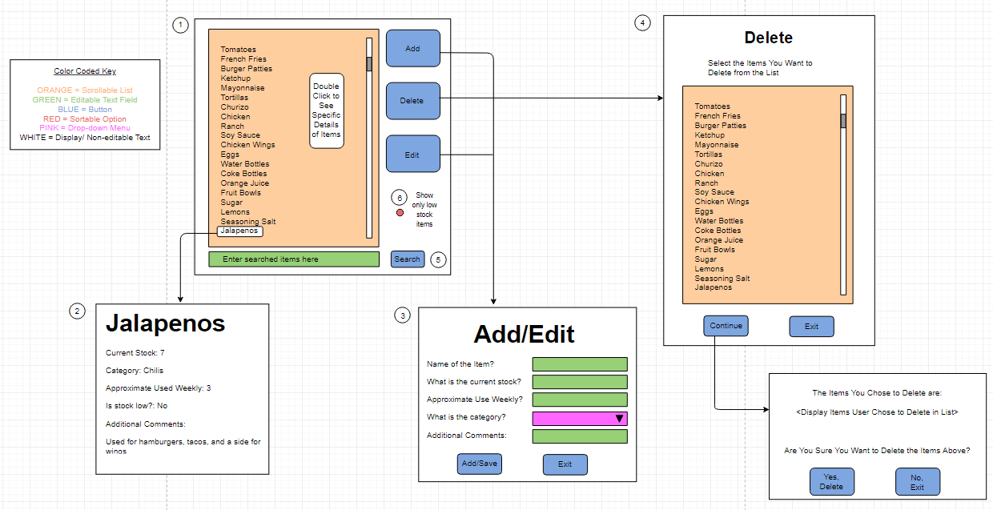

Descriptions of Main Features & Functions

- Main Menu Display

- Item Display

- Add Button /Edit Button

- Delete Button

- Search Button

- Sort Button

Flow Chart:

